DATABASE MANAGEMENT SYSTEM LAB RECORD
Course Code: ENCS254
Program: B.Tech CSE – Semester IV
Session: 2024–25 (Even)
Name: Utsah Singhal
University: K.R. Mangalam University

Experiment No. 1 – College Database

Aim:
To design ER diagram for College Database and implement it using SQL.

Entities and Attributes:
STUDENT (USN – PK, StudentName, Address, Phone, Gender)
SEMSEC (SSID – PK, Sem, Sec)
SUBJECT (Subcode – PK, Title, Sem, Credits)
IAMARKS (USN – FK, Subcode – FK, SSID – FK, Test1, Test2, Test3, FinalIA)

Relationships:
1. CLASS: One SEMSEC has many STUDENTS (1:N).
2. STUDENT–IAMARKS: One student can have multiple marks records (1:N).
3. SUBJECT–IAMARKS: One subject can have marks of many students (1:N).

SQL – DDL:
CREATE TABLE STUDENT (
USN VARCHAR(20) PRIMARY KEY,
StudentName VARCHAR(50),
Address VARCHAR(100),
Phone VARCHAR(15),
Gender VARCHAR(10)
);
CREATE TABLE SEMSEC (
SSID VARCHAR(10) PRIMARY KEY,
Sem INT,
Sec VARCHAR(5)
);
CREATE TABLE SUBJECT (
Subcode VARCHAR(10) PRIMARY KEY,
Title VARCHAR(50),
Sem INT,
Credits INT
);
CREATE TABLE CLASS (
USN VARCHAR(20),
SSID VARCHAR(10),
PRIMARY KEY (USN, SSID),
FOREIGN KEY (USN) REFERENCES STUDENT(USN),
FOREIGN KEY (SSID) REFERENCES SEMSEC(SSID)
);
CREATE TABLE IAMARKS (
USN VARCHAR(20),
Subcode VARCHAR(10),
SSID VARCHAR(10),
Test1 INT,
Test2 INT,
Test3 INT,
FinalIA INT,
PRIMARY KEY (USN, Subcode, SSID),
FOREIGN KEY (USN) REFERENCES STUDENT(USN),
FOREIGN KEY (Subcode) REFERENCES SUBJECT(Subcode),
FOREIGN KEY (SSID) REFERENCES SEMSEC(SSID)
);
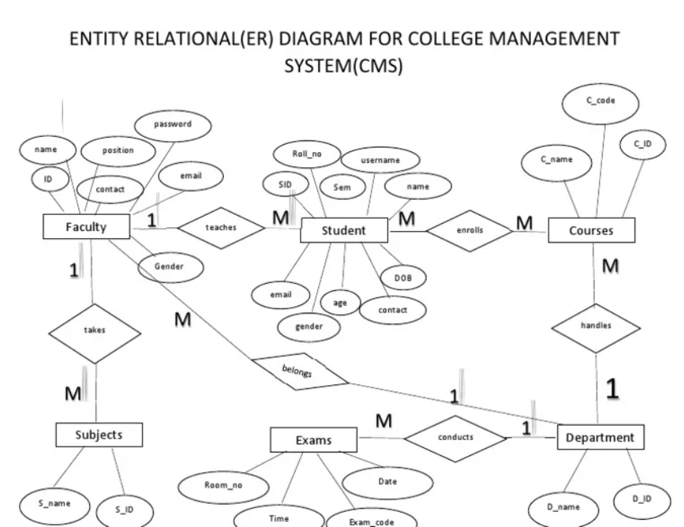

Experiment No. 2 – Company Database

Aim:
To design ER diagram for Company Database and implement using SQL.

Entities and Attributes:
EMPLOYEE (SSN – PK, Name, Address, Sex, Salary, Superssn, Dno)
DEPARTMENT (Dno – PK, Dname, Mgrssn, Mgrstartdate)
PROJECT (PNo – PK, PName, PLocation, DNo – FK)
WORKS_ON (SSN – FK, PNo – FK, Hours)

Relationships:
1. EMPLOYEE–DEPARTMENT: One department has many employees (1:N).
2. DEPARTMENT–PROJECT: One department controls many projects (1:N).
3. EMPLOYEE–PROJECT: Many-to-Many relationship resolved using WORKS_ON (M:N).

SQL – DDL:
CREATE TABLE EMPLOYEE (
SSN INT PRIMARY KEY,
Name VARCHAR(50),
Address VARCHAR(100),
Sex VARCHAR(10),
Salary INT NOT NULL,
Superssn INT,
Dno INT
);
CREATE TABLE DEPARTMENT (
Dno INT PRIMARY KEY,
Dname VARCHAR(50),
Mgrssn INT,
Mgrstartdate DATE
);
CREATE TABLE PROJECT (
PNo INT PRIMARY KEY,
PName VARCHAR(50),
PLocation VARCHAR(50),
DNo INT,
FOREIGN KEY (DNo) REFERENCES DEPARTMENT(Dno)
);
CREATE TABLE WORKS_ON (
SSN INT,
PNo INT,
Hours INT,
PRIMARY KEY (SSN, PNo),
FOREIGN KEY (SSN) REFERENCES EMPLOYEE(SSN),
FOREIGN KEY (PNo) REFERENCES PROJECT(PNo)
);

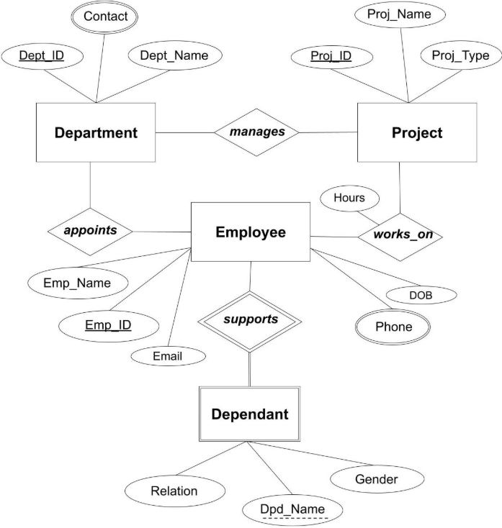

Experiment No. 3 – Customer Sale DatabasE

Aim:
To design and implement Customer-Sale schema using SQL.

Entities and Attributes:
CUSTOMER (Cust_id – PK, Cust_name)
ITEM (Item_id – PK, Item_name, Price)
SALE (Bill_no, Bill_date, Cust_id – FK, Item_id – FK, Qty_sold)

Relationships:
1. CUSTOMER–SALE: One customer can generate multiple bills (1:N).
2. ITEM–SALE: One item can appear in multiple sales (1:N).

SQL – DDL:
CREATE TABLE CUSTOMER (
Cust_id INT PRIMARY KEY,
Cust_name VARCHAR(50)
);
CREATE TABLE ITEM (
Item_id INT PRIMARY KEY,
Item_name VARCHAR(50),
Price INT NOT NULL
);
CREATE TABLE SALE (
Bill_no INT,
Bill_date DATE,
Cust_id INT,
Item_id INT,
Qty_sold INT,
PRIMARY KEY (Bill_no, Item_id),
FOREIGN KEY (Cust_id) REFERENCES CUSTOMER(Cust_id),
FOREIGN KEY (Item_id) REFERENCES ITEM(Item_id)
);

SQL – DML (Sample Inserts):
INSERT INTO CUSTOMER VALUES (1,'Aman'),(2,'Riya'),(3,'Rahul');
INSERT INTO ITEM VALUES (101,'Laptop',50000),(102,'Mouse',500);
INSERT INTO SALE VALUES (1,CURDATE(),1,101,1),(2,CURDATE(),2,102,2);

SQL – Query Example:
SELECT s.Bill_no, i.Price, s.Qty_sold,
(i.Price * s.Qty_sold) AS Total_Amount
FROM SALE s
JOIN ITEM i ON s.Item_id = i.Item_id;

SQL – View Creation:
CREATE VIEW Bill_Details AS
SELECT s.Bill_no, s.Bill_date, s.Cust_id,
s.Item_id, i.Price, s.Qty_sold,
(i.Price * s.Qty_sold) AS Amount
FROM SALE s
JOIN ITEM i ON s.Item_id = i.Item_id;
